

**Digital Empowerment Pakistan**

**TASK#01**

**Submitted by:**

**MUBASHRA MOBEEN MALIK**

**WEB DEVELPOMENT INTERNSHIP**

**TASK:**

Build a simple static website using HTML and CSS, showcasing your personal profile or a hobby.

**CODE:**

<!DOCTYPE html>

<html lang="en">

<head>

<meta charset="UTF-8">

<meta name="viewport" content="width=device-width, initial-scale=1.0">

<title>My Personal Profile</title>

<style>

    body {

        font-family: Arial, sans-serif;

        background-color: #f0f0f0;

        margin: 0;

        padding: 0;

    }

    .container {

        max-width: 800px;

        margin: 20px auto;

        background-color: #fff;

        padding: 20px;

        border-radius: 8px;

        box-shadow: 0 0 10px rgba(0,0,0,0.1);

    }

    h1 {

        text-align: center;

        color: #0f0404;

    }

    .profile-img {

        display: block;

        margin: 20px auto;

        border-radius: 50%;

        max-width: 200px;

        height: auto;

    }

    p {

        line-height: 1.6;

        color: #666;

    }

    ul {

        list-style-type: none;

        padding: 0;

    }

    ul li {

        margin-bottom: 10px;

    }

</style>

</head>

<body>

<div class="container">

    <h1>Mubashra Malik</h1>

    <p>Web Developer &amp; Designer</p>

    <h2>About Me</h2>

    <p>I am passionate about web development and enjoy creating user-friendly and visually appealing websites. I am studdying software engineering from hitec university taxila.</p>

    <h2>Hobbies</h2>

    <ul>

        <li>Playing guitar</li>

        <li>Reading books</li>

        <li>Hiking in nature</li>

    </ul>

    <h2>Contact</h2>

    <ul>

        <li>Email: mubashra.14@gmail.com</li>

        <li>Phone: +1234567890</li>

        <li>Website: <a href="https://www.mubashra.com">www.mubashra.com</a></li>

    </ul>

</div>

</body>

</html>

**Output:**

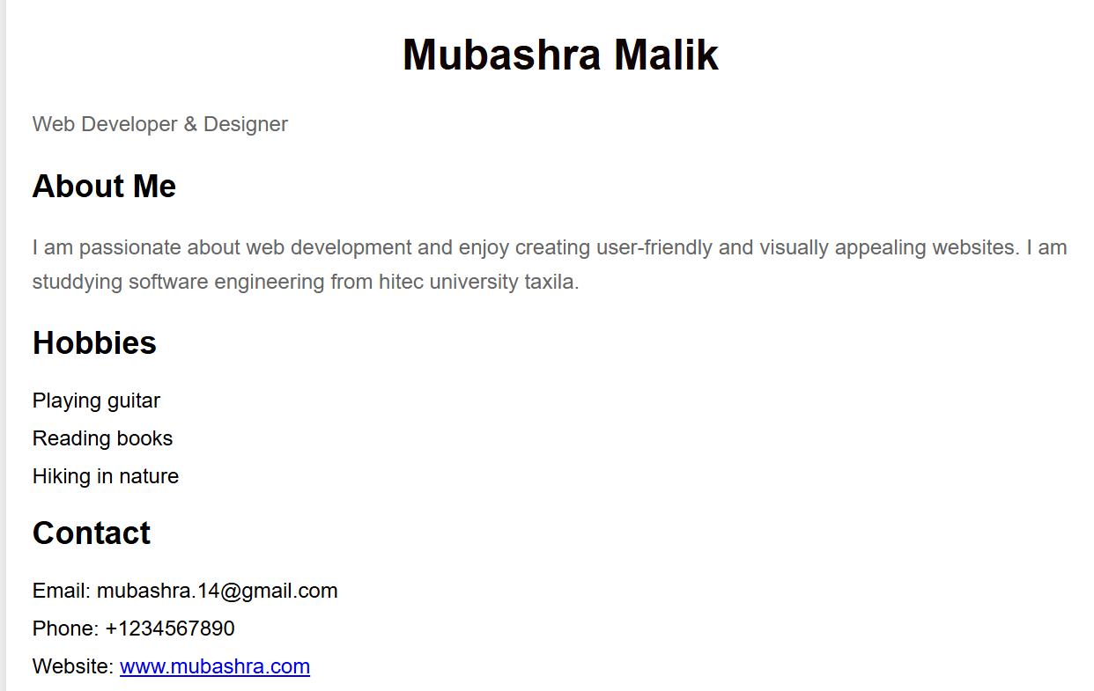

**Explanation:**

* **HTML Structure:**
  + The HTML structure includes basic sections for a profile, hobbies, and contact information.
* **CSS (Internal)**:
  + Styles are applied internally using the <style> tag within the <head> section.
  + body sets the overall font, background color, and margins.
  + .container styles the main content area with a white background, padding, border radius, and box shadow for a card-like appearance.
  + Various other styles (h1, p, ul, li, .profile-img) define typography, colors, and spacing throughout the document.
  + Responsive design considerations (max-width, margin: auto)
  + the content is centered and adapts to different screen sizes.

**Conclusion:**

This example provides a basic template for showcasing a personal profile or hobby using HTML and CSS. The footer adds a professional touch, indicating ownership and copyright information. Adjust and expand the content and styles according to your preferences and needs.